Car Breezy

User Guide

|  |  |  |
| --- | --- | --- |
| Supervisor. | MISS RAMSHA |  |
| Batch. | 2310F1 |  |
| Group. | A |  |
| Serial No. | Enrolment Number | Student Name |
| 1. | Student1521664 | ANMOL NAZ |
| 2. | Student1521662 | HAFSA ABID LODHI |
| 3. | Student1527146 | HAREEM FATIMA |
| 4. | Student1525611 | SABA |

**Let’s embark on a journey of discovery with Car Breezy. This guide is designed to Assist You every step of the way!**

Now let’s delve into a detailed explanation of our user guide, ensuring that every aspect of our website becomes accessible and understandable.

**Now starting with a closer look at our navigation bar.**

The navigation bar located prominently at the top of the page, serves as your compass through our website. Following is the image how the navigation bar looks like;



It provides quick access essential sections and features, ensuring seamless navigation.

Let’s break the navigation bar in sections and understand thoroughly;

**SECTION 1** explains the visitor counter present in our navigation bar;

Following image shows the visitor counter;



The visitor counter is a handy tool integrated in our website to provide real time insights into a number of visitors accessing our platform.

**HOW IT WORKS?**

The visitor counter located at top left on our website displays the total number of visitors who have accessed our website within a specific timeframe. This count is dynamic and updates in real time, reflecting the current influx of visitors exploring our platform.

**SECTION 2** explains the important information which can be seen in animated form in our website navigation bar;

This is how animated text looks like:





You may have noticed that at certain intervals, a text animation appears on the top of the screen. These animations alternate between two messages. The dynamic animated texts are designed to convey important messages and information to our visitors.

**SECTION:03** explains you the working of our navigation bar;

Following image shows the navigation menu present in navigation bar:



NAVIGATION MENU:

Our navigation menu serves as a roadmap, guiding you through the various sections and pages of our website. With intuitive labels and organized categories, navigationg through our content is a breeze. Let’s take a closer look at each menu item:

1. Home:

Clicking on “home” will take you to the main landing page of our website,where you can explore featured content and explore other sections.

2. Blogs:

Selecting “Blogs” will direct you to a collection of our latest articles which keeps you informed and entertained.

3. Categories:

Hover over categories to reveal a dropdown menu with several options:

This is how dropdown looks like when you hover over categories:

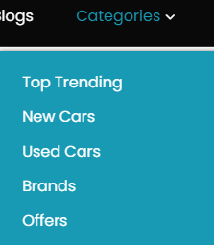

Top Trending: Explore the latest trends and popular topics in the automotive industry.

Used Cars: Browse our collection of pre-owned vehicles with detailed listings and information.

New Cars: Discover the new models and releases from leading manufacturers.

Brands: Learn more about the automotive brands we feature on our website.

Offers: Find special deals, promotions and discounts on automotive products and services.

4. Accessories:

Click on accessories to discover a range of automotive accessories which enhances your driving experience.

5. About:

Navigate to our “about” to learn more about our website, services, location, giving you insight into who we are and what we do.

6. Contact:

Our contact page offers various methods for getting in touch with us, providing convenient options for reaching out and obtaining assistance.

While the main “contact” page is accessible and functional, certain dropdown options are currently under development and not accessible to users.

Dropdown options:

This is how contact dropdown looks like:

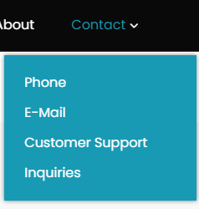

* *Current Status:*

While these dropdown options are visible, they are currently in development and not operational. Clicking on any of these dropdown options will not lead to a relative page at this time.

We appreciate your patience as we work diligently to finalize and launch these additional contact options.

**SECTION:04** explores the cart feature present in navigation bar. Let’s take a closer look at how it simplifies the process of managing and purchasing your favorite items.

First have a look at how cart looks like in navigation bar;



Our cart feature provides a convenient way for you to keep track of items you wish to purchase while browsing our website.

HOW IT WORKS:

* Accessing the cart:

Look for the shopping cart icon in the navigation bar at the top of the page. Clicking on that icon will take you to another page. There clicking on the cart icon will open the cart tab, displaying the summary of items you have added.

Here’s how the cart tab looks like:

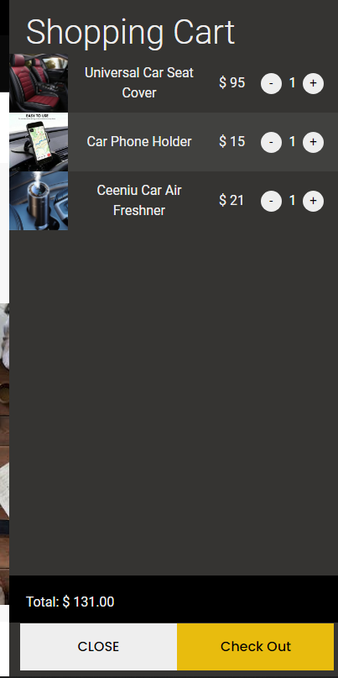

* Adding Items:

While browsing our accessories page, you will find a variety of products available for purchase. Each product listing would include an option to ‘Add to Cart’. Clicking on this button will instantly add the item to your cart.

Here’s how ‘add to cart’ button looks like on accessories page;

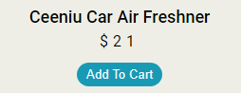

* Viewing Cart Contents:

Once you’ve added items to your cart, you can access the car tab by clicking on the shopping cart icon. Here you’ll see the list of all items you have added, along with their details such as quantity and price.

BENEFITS:

* Convenience:

The cart feature allows you to collect items of interest as you browse our website, streamlining the checkout process when you have ready to make a purchase.

Follow these simple steps to proceed with checkout:

1. Accessing the cart:

Begin by clicking the shopping cart icon in the navigation bar at the top of the page. Clicking on this icon will open the cart tab, displaying the summary of items you have added.

2. Proceed to Checkout:

With in the cart tab locate the ‘checkout’ button and click on it to initiate the checkout process.

Here’s the checkout button inside cart tab.

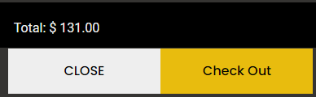

Clicking on checkout button will open a form where you can enter your details and complete your purchase.

This is how form looks like:

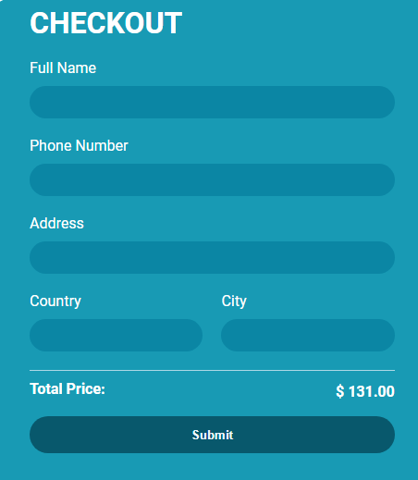

3. Filling Out the Form:

Once the checkout form is open, fill out the required fields with your information. Ensure the all information provided is accurate and up to date.

4. Submitting the Form:

After filling out the form, review your information to confirm its accuracy. Once satisfied click the submit button to submit the form for processing.

Submit Button:

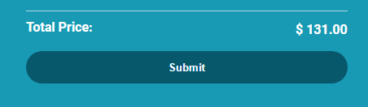

5. Confirmation:

Upon successful submission of the form, you will receive a confirmation message indicating that your form has been submitted. This message serves as assurance that your order has been received and will be processed accordingly.

Something like this;

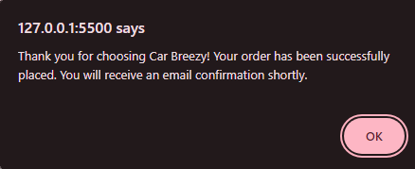

USAGE TIPS:

* Review and Edit:

Take advantage of the cart tab to review the items you have added. You can adjust quantities, remove items or continue shopping as needed before finalizing your purchase.

Following is the image description from which the user can add or remove product from cart;

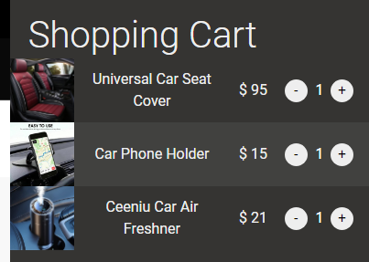

* Save for Later:

If you are not ready to make a purchase immediately, you can also use the cart to save items for your consideration. Simply leave them in your cart until you are ready to proceed.

**SECTION:05** explains the terminology of search bar.

Our search functionality is currently in development and will soon provide you with a powerful tool for finding cars and related information on our website quickly and easily. Although clicking the search icon does not currently produce any results, rest assured that we are working diligently to implement this feature and enhance your browsing experience.

**HOW IT WILL WORK?**

Upon completion, clicking on the search icon will open a search bar where you can enter keywords or phrases related to the cars you’re interested in. The search results will then display related listings, allowing you to explore available cars and find the perfect match for your needs.

And that concludes our overview of the navigation bar.

**Let’s explore the heart of our website, where we share valuable insights, tips and updates on ‘car breezy’.**

Before going to the description of the page let’s see how it looks like.

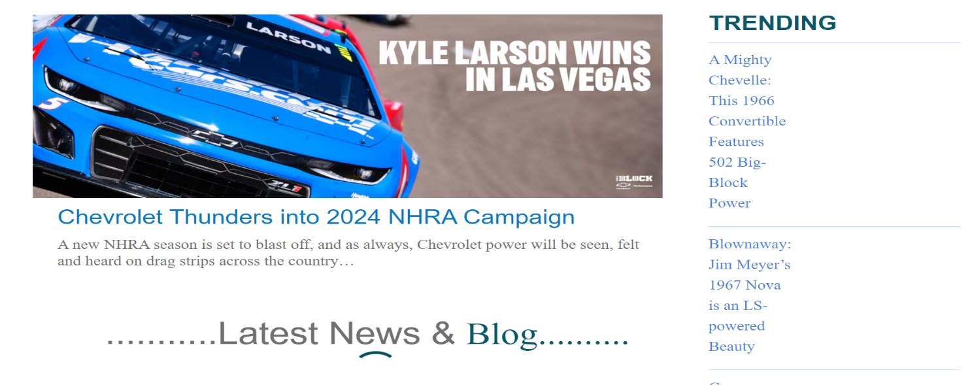

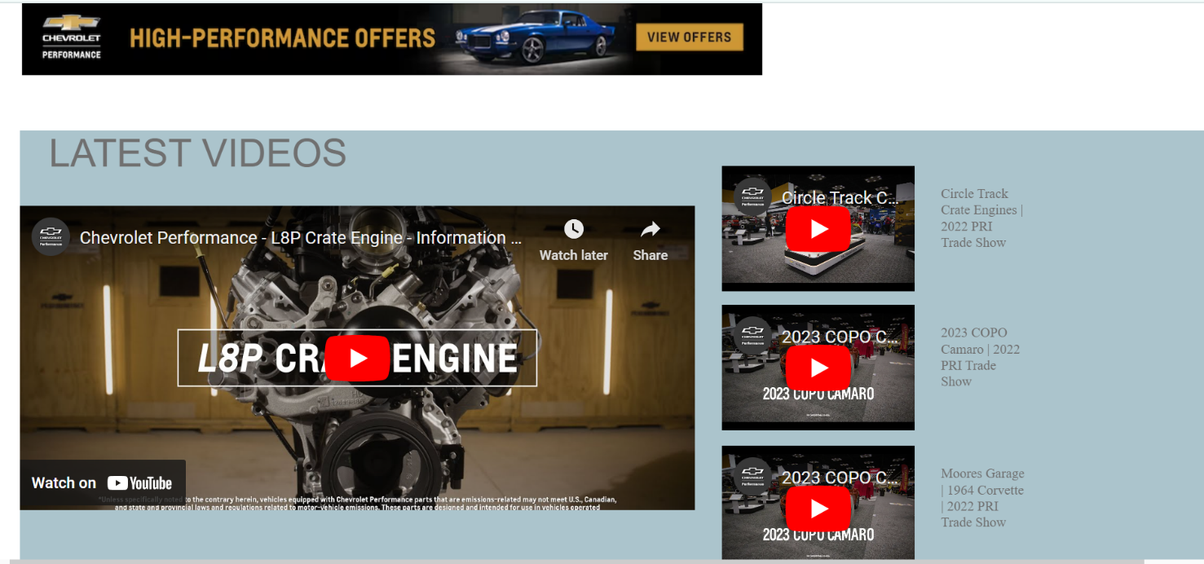



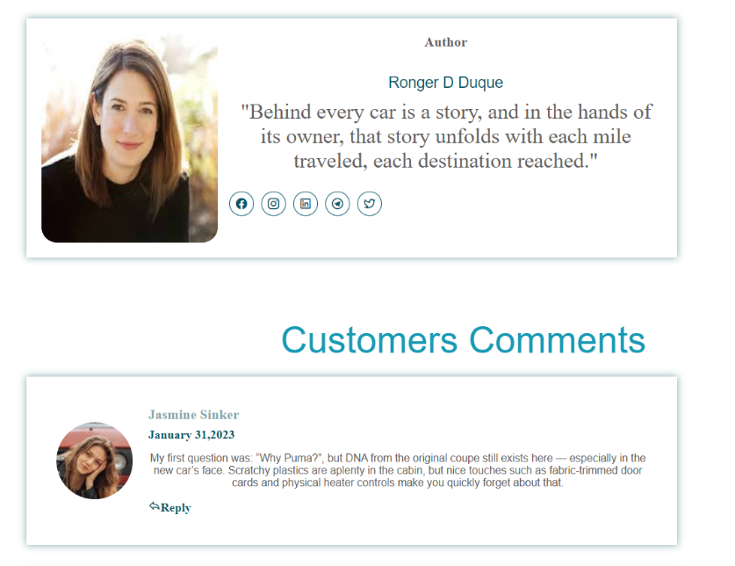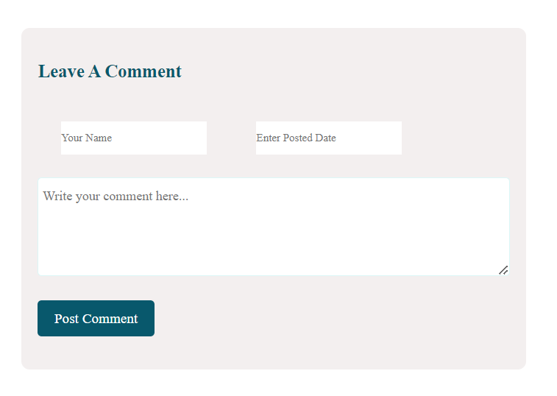

Let’s explore the features and functionality of ‘blog’ page;

1. Accessing the Blog: You can access the blog page by clicking on the ‘Blog’ menu in the navigation bar at the top of the website.

2. Overview: Our Blog page is a treasure trove of information, featuring articles, and thought-provoking pieces written by experts in the field.

3.Content Display: On the Blog page, you’ll find a dynamic display of posts, with the latest articles showcased prominently for east access.

4.Reading and Interacting: Dive into any post to read engaging content and interact with the author and other readers through comments and social sharing options.

5.Feedback and Support: We value your feedback! Feel free to leave comments on our posts.

Here ends to the description of our ‘Blog’ page.

**Let’s begin our exploration of the website by taking a closer look at the vibrant heart of it all – our home page.**

Let’s break the home page in sections and understand thoroughly;

**SECTION 1** gives you the visual presentation of our animated banner in the home page.

Our home page features a captivating and visually stunning banner that serves as the focal point upon arrival. This eye- catching element not only enhances the aesthetics of our website but also provide users with an engaging preview of our brand and product.

Banner can be seen visually in following image;

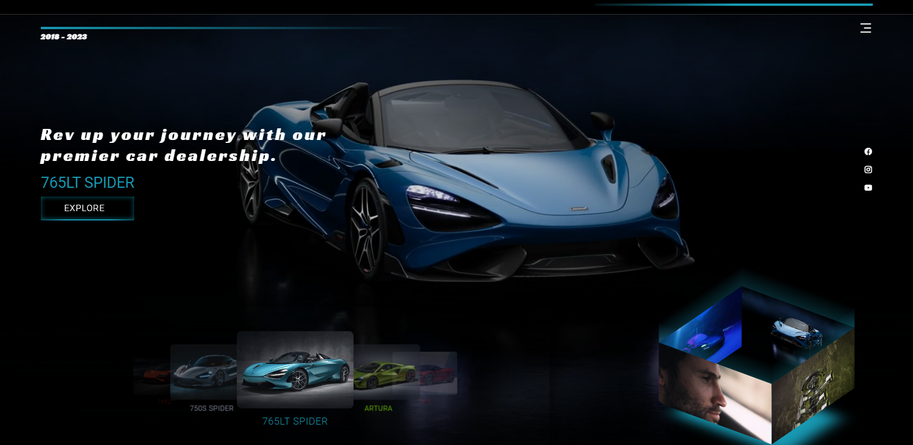

**SECTION 2** is designed to facilitate the process of buying vehicles, providing users with access to a wide range of options and resources.

Following is how are car dealer section looks like;

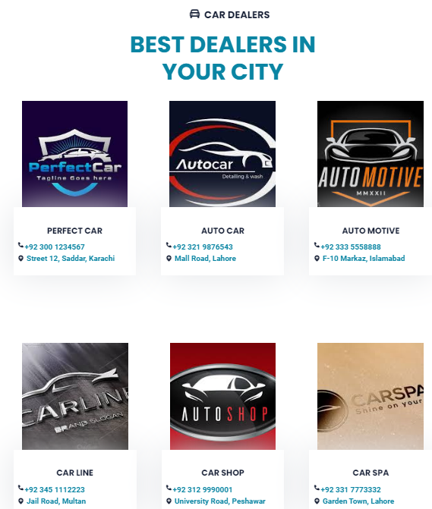

Convenience: The car dealer section streamlines of buying car by providing all the necessary information in one centralized location.

Variety: With a wide selection of dealerships and sellers to choose from, users have the freedom to explore different options and find the perfect vehicle to suit their needs and preferences.

**SECTION 3** steps into the spotlight with our reels section, where each video is a masterpiece waiting to be explored. Get ready to immerse yourself in the sights and sounds of the automotive realm.

Following image shows our reels section;

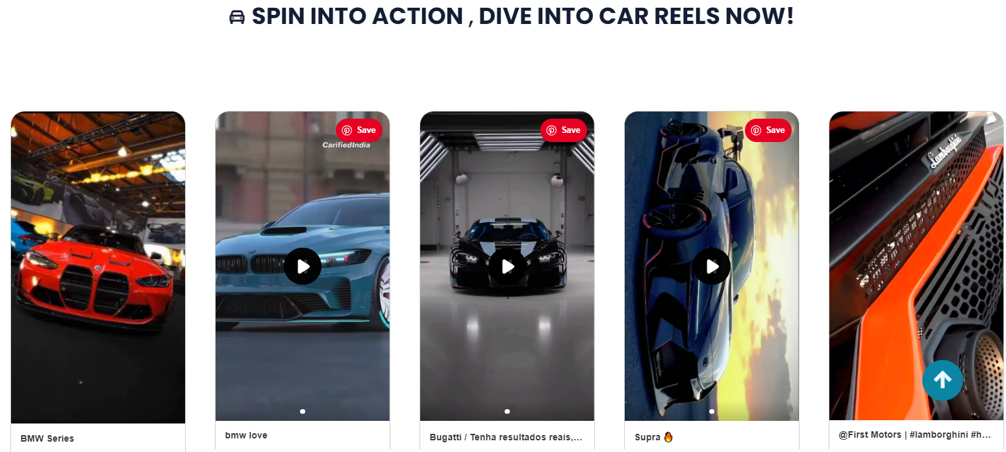

Our reels section is an exciting and dynamic showcase of car videos that brings the thrill of the road to your screen. Immerse yourself in the word of automobiles as you explore captivating videos featuring the latest models, driving experience, and automotive adventures.

**SECTION 4** describes the details about latest cars;

The latest car section of our website provides users with an up-to-date showcase of the newest vehicles available in the market, top trending cars, vehicles on special offers or pre-owned options, this section serves as your gateway to discovering the most recent additions to the automotive world.

The following image shows how our latest car section looks like;

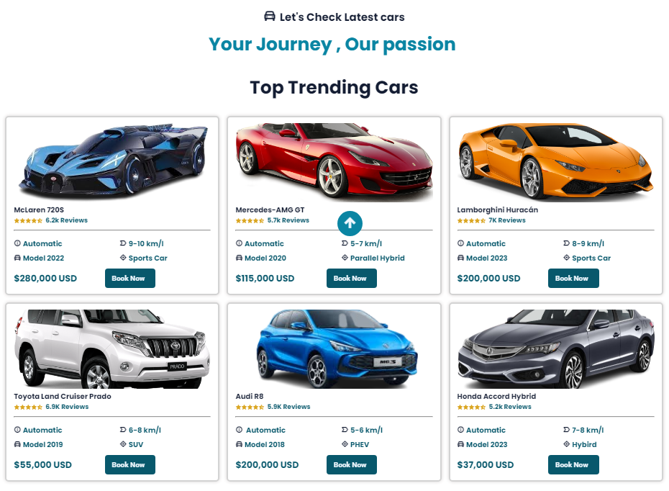

**Subsections:**

1. Top Trending:

The picture shows the visual presentation of top trending section;

In this subsection, you will find a curated selection of hottest and most sought-after vehicles of the moment. These cars represent the latest trends in designs, technology and performance.

2. Cars in Offers:

The following image shows the offer section;

Explore this sub section to discover exciting deals and promotions on a variety of vehicles. You’ll find compelling incentives to make your next car purchase even more rewarding.

3. New Cars:

Here you’ll find comprehensive listings of brand-new cars. From compact city cars to rugged SUVs and luxurious Sedans, this subsection showcases the newest arrivals from leading automotive manufactures.

4. Used Cars:

If you’re considering a pre-owned vehicle, this subsection is your destination. Browse through a diverse of high quality used-cars, each accompanied by detailed descriptions and imagery to help you make an informed decision.

Booking Process: When you’re ready to proceed with booking a car , simply click on the ‘Book Now’ button associated with your preferred vehicle. You’ll be guided through a streamlined booking process. Specify your preferences, and finalizeyour reservation with ease.

**Book Now**

**SECTION 5** looks the following;

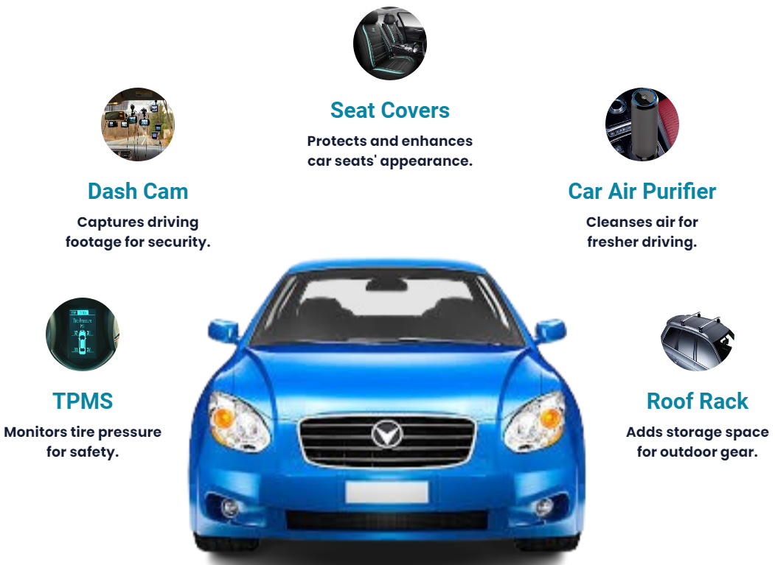

**SECTION 6** looks the following;

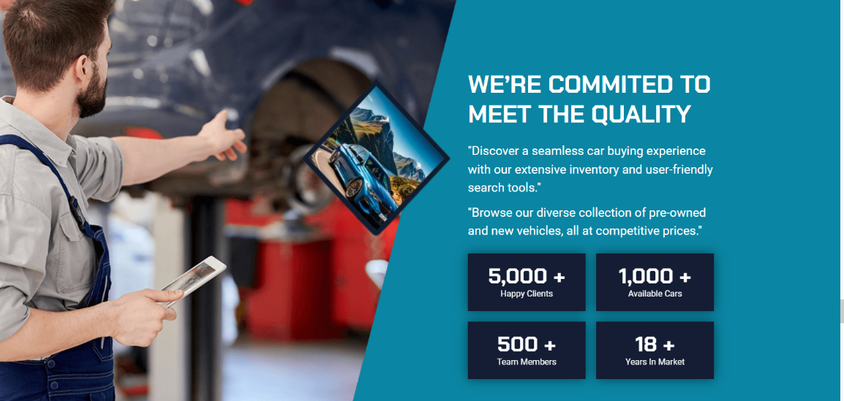

**SECTION 7** of our website offers valuable insights and feedbacks from customers who have experienced our services.

Let’s have a look at this section;

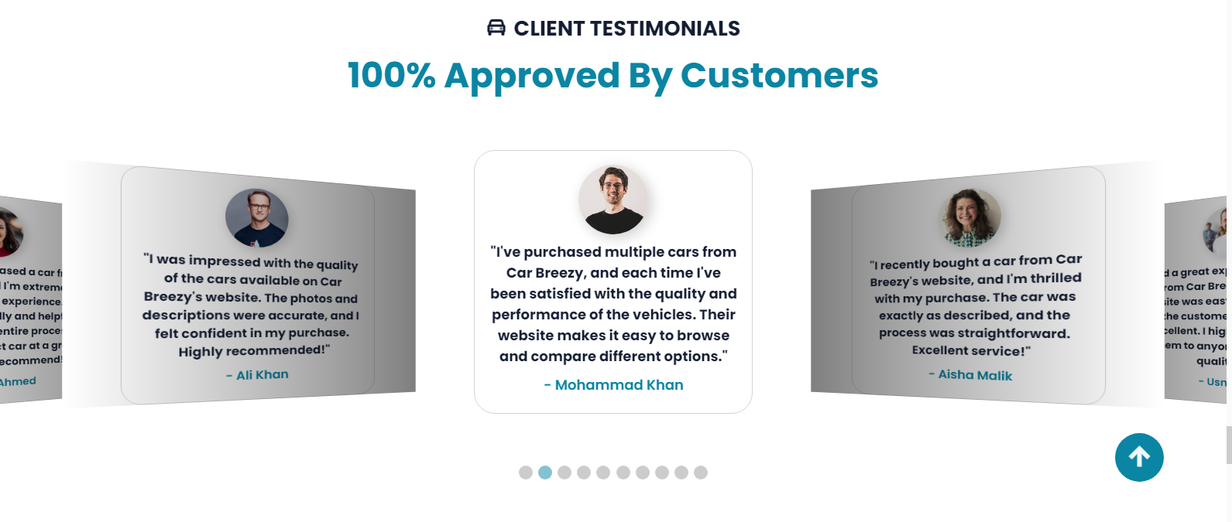

The primary objective of the client reviews section is to provide transparency and authenticity by showcasing genuine feedback from individuals who have interacted with our services. By reading through these reviews, user can gain a deeper understanding of the strengths, benefits and potential areas for improvement of our offerings.

**SECTION 8** shows the visual presentation of our app.

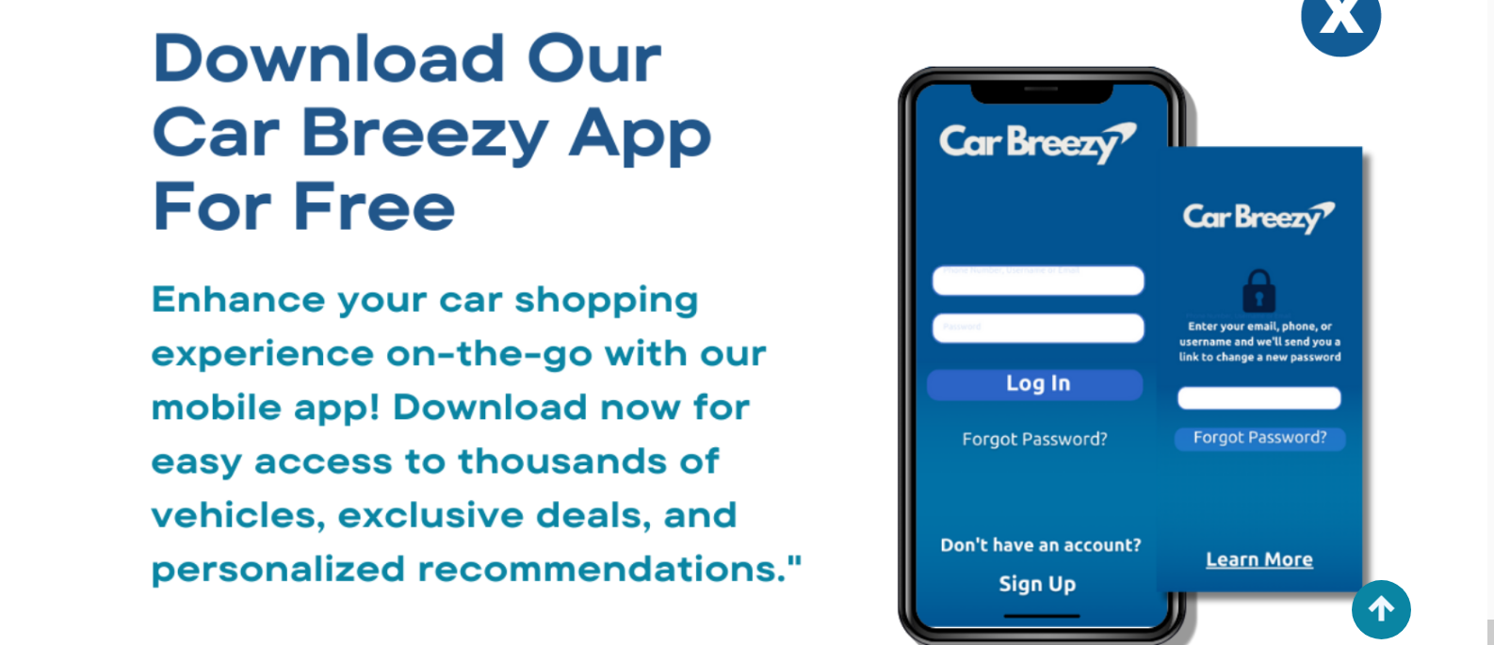

The app can be downloaded from google play store. One can access the app with more enhanced features and functionality.

**SECTION 9** allows you to subscribe to our newsletter to get latest updates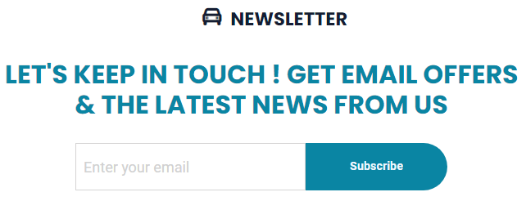The “subscription” section of our website enables you to stay updated with our latest updates and promotions.

**HOW TO SUBSCRIBE?**

1. Enter Your Mail: Enter your email address in the designated field with the placeholder ‘Enter your mail’. The mail should be the one where you would like to receive updates and newsletters.

2. Click Subscribe: Once you’ve entered your e-mail address, click on the ‘Subscribe’ button to confirm your subscription request.

3.Confirmation Alert: Upon successful subscription, you’ll receive a confirmation alert acknowledging your subscription.

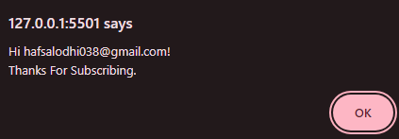

Here comes to an end for the description of our ‘Home’ page.

**Let’s Explore a diverse array of cars spanning various makes, models and body types in our ‘Categories’ page.**

Let’s start describing each aspect of it;

The ‘categories’ page of our website serves as a comprehensive directory of available vehicles.

Let’s have a look how the page looks like to understand the functionality in a far better way;

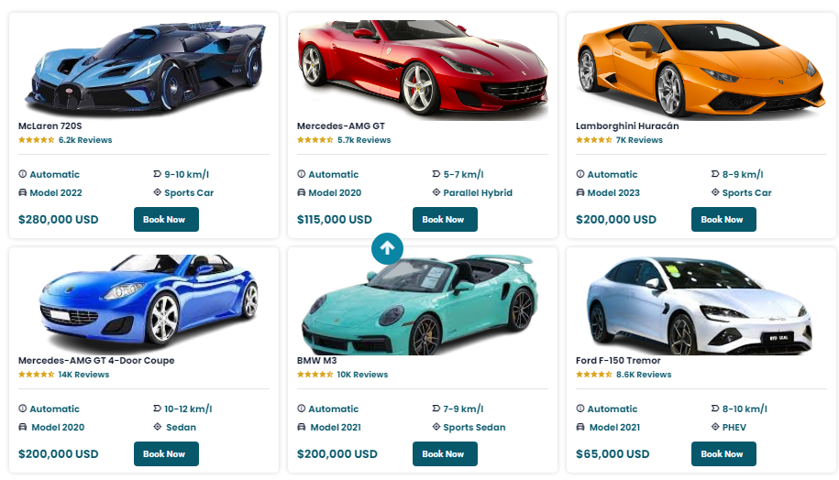 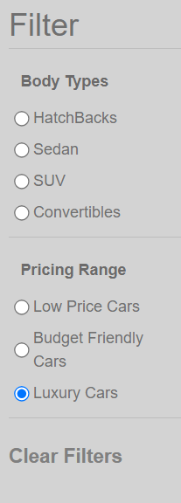

**Key Features:**

1. Car Cards: The main section of the page consists of cards representing individual cars. Each card provides essential information such as car model, image and pricing.

2. Filter Box: Located prominently on the page, the filter box offers users the ability to refine their search based on specific criteria. The filter box includes the following options;

* **Body Types:** Users can select from a variety of body types including hatchbacks, sedans, SUVs and convertibles. Selecting a body type will filter the car cards to display only vehicles matching the chosen category.

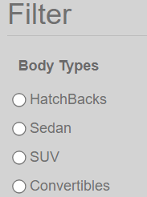

* **Pricing Options:** Users can filter cars based on pricing options such as low price or budget friendly cars. This allows users to narrow down their search to vehicles that fit within their desired price range.

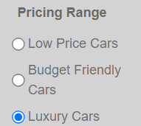

* **Clear Filter Option:** To reset the filter and view all available cars without any applied criteria, users can simply click on the ‘clear filter’ option. This provides a quick and convenient way to start a new search or explore the full range of options.



**How to Use the Filter Functionality?**

1. Select Body Type: Choose the desired body type from the available options under the Body type heading in filter box. The car cards will automatically update to display only vehicles matching the selected body type.

2.Choosing Pricing options: If desired, select the pricing option from the available option under the pricing range heading in the filter box to further refine the search based on budget preferences. The car cards will update accordingly to reflect the chosen pricing criteria.

3.Clear Filters: To remove any applied filters and view all available cars regardless of a body type or pricing, simply click on the ‘Clear Filter’ option within the filter box.

Here comes to an end for the description of categories page.

**Explore our curated selection of car accessories designed to enhance every aspect of your journey.**

The ‘Car Accessories’ page of our website offers a wide selection of products designed to enhance your driving experience. From practical gadgets to stylish enhancements, our range of accessories is sure to meet your range.

**PRODUCT CARDS:**

Each product is showcased on a card featuring its name, image, price and ‘add to cart’ button.

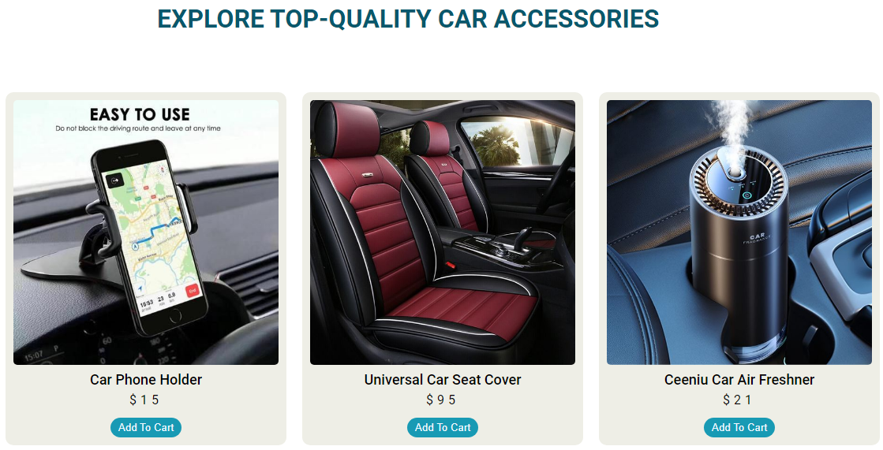

Clicking on the image of any product card will redirect you to the products detailed description page, providing you with comprehensive information about its feature and specifications.

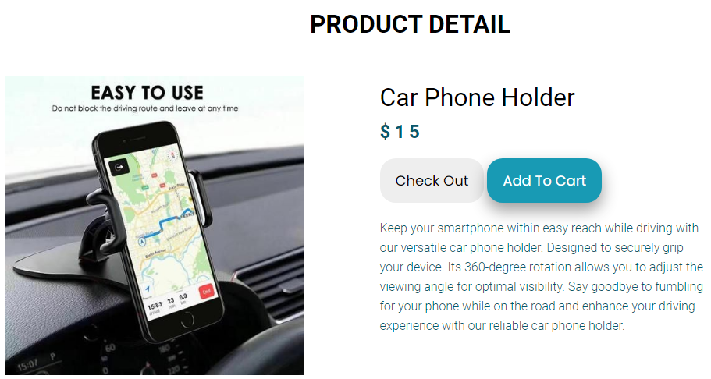

Inside product detail page we also have similar product section;

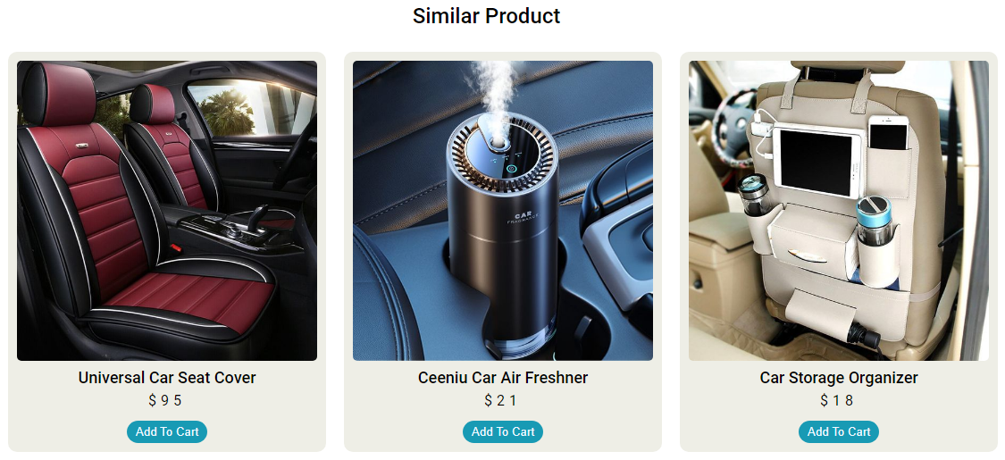

The product cards inside similar products can be accessed as same as the cards work on main page.

**ADDING PRODUCTS TO CART:**

Simply click on the ‘add to cart’ button associated with any product to add it to your shopping cart.

Add To Cart

Upon Clicking the number on the cart icon will increment, indicating the addition of the product to your cart.

**The detailed functionality of the cart tab is described along with the description of navigation bar.**

Here the description about accessories page comes to an end.

**Now let’s together through the narrative of Car Breezy - a place where passion meets purpose, and users are at the forefront of everything we do. Let’s take a look at About us page present in our website.**

As you click on “About’ present in our navigation bar will direct you to the ‘about us’ page in our website. Let’s see that how it looks like.

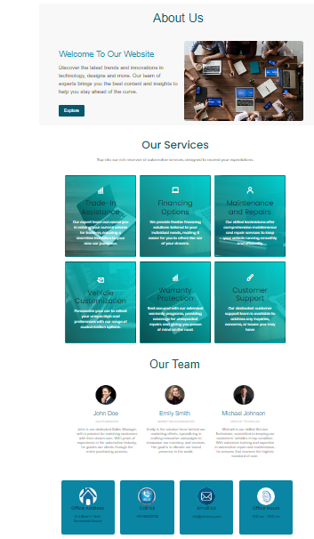

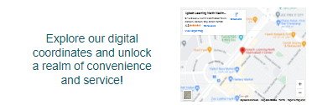

Let’s break the page in different sections:

**SECTION:01** explains banner present on “about us” page;

Here you can see the banner with close picture that explains the basic objective of our organization.

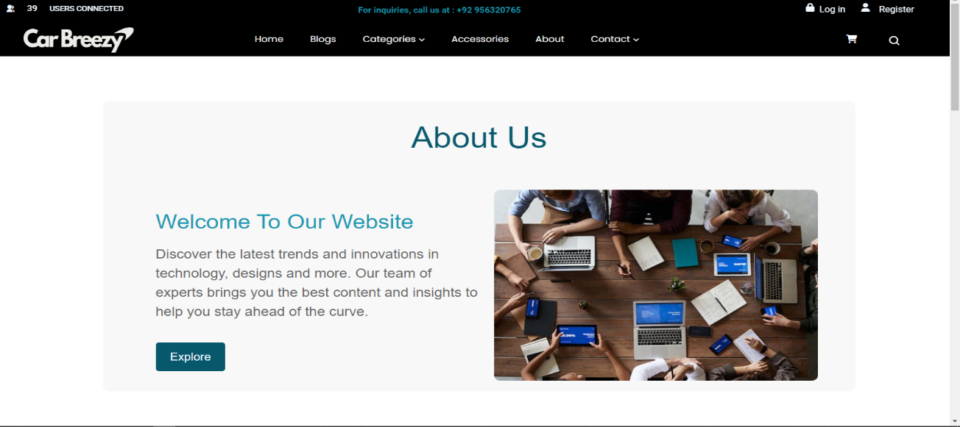

You can notice a button named “Explore” in it. Clicking this button will take you to the categories page whose working is also described further in this user guide.

**SECTION:02** explains our services section present on “about us” page;

Next to it we have our services card. Also have a close shot of that also.

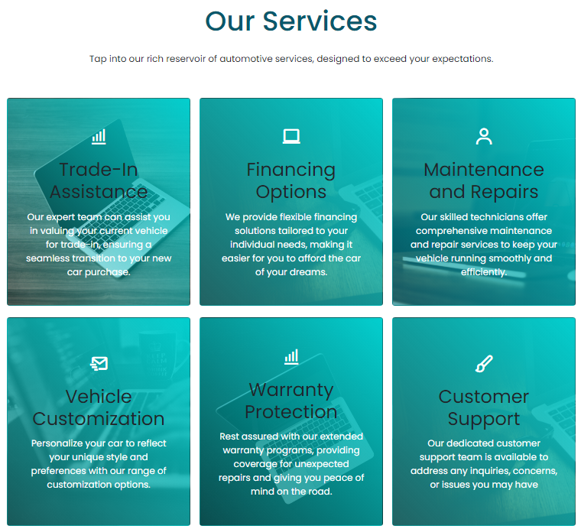

Explore our comprehensive suite of services tailored to meet your automotive needs. Also Learn how our team of skilled technicians ensures top-notch service and customer satisfaction with every visit.

**SECTION:03** explains our team section present on “about us” page;

Also have a close shot of that also.

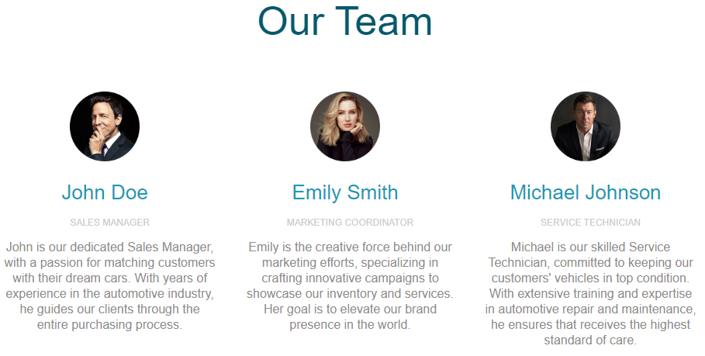

Learn about the dedicated individuals who form the backbone of our company in the 'Our Team' section.The faces behind our brand and the diverse expertise they bring to our organization.You can see profiles of our talented team members, each contributing their unique skills to our shared vision.

**SECTION:04** of the user guide contains necessary information about our store. From addresses to operating hours, contact number to essential information.

This section aims to provide users with all necessary information they need to interact with our store seamlessly.

Let’s experience it visually in the following image;

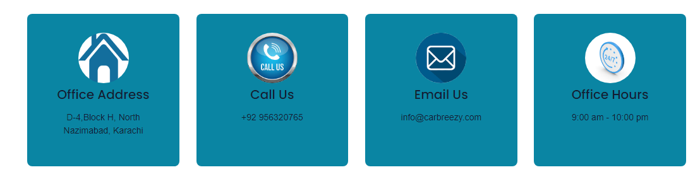

This section of the website provides concise yet comprehensive information about our various locations through visually appealing cards. Each card contains essential details such as the address, contact number, opening hours, and other pertinent information, allowing users to easily find and interact with our locations.

**SECTION:05** turns your attention to the comprehensive roadmap of our website – the location map. Discover how this invaluable tool can help navigate through our location with ease.

Site map looks something like this in ‘about’ page;

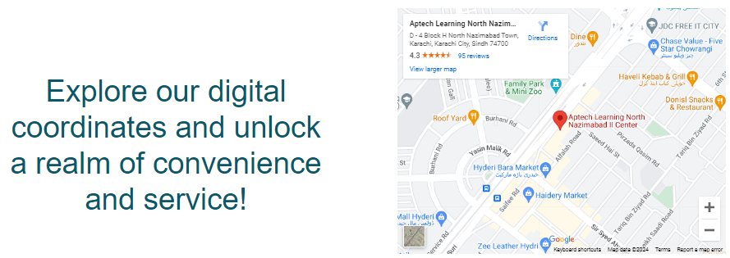

Our location map provides an interactive and intuitive way for you to find the physical location of our office. This map feature offers real-time navigation to guide you to our doorstep.

HOW IT WORKS:

Simply click the map to interact with it. You can zoom in and out, drag the map to view different areas. Use (+) and (-) buttons for zooming in and out.

Thus, concludes the narrative of our ‘about us’ page description.

**Let’s talk about the contact page which is the last one in our website.**

Learn how to reach out to our team directly through our dedicated contact service.

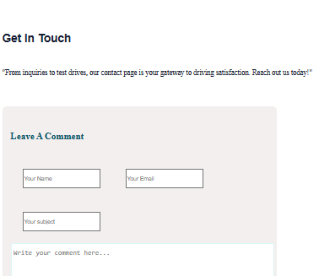

The contact page provides users with a direct and easily accessible means of getting in touch with the website owner, company, or support team.

**Thank you for reading our user guide. We hope this guide has provided you with a comprehensive understanding of our website’s features and functionalities. By utilizing the tools and resources outlined in this guide, you can enhance your experience and make the most out of your time on our platform.**

**If you have any questions or need further assistance, please don’t hesitate to reach out to our support team. We’re here to help you every step of the way.**

Happy Exploring!

Designed by: Hafsa Lodhi